1

TITLE :
Signal Sentinel: Sentiment Analysis System based on Natural Language Processing to detect emotional signals.
TEAM DETAILS :
NAME | HALLTICKECT
K.RISHIK | 2403A52263
J. SIDDHARTHA | 2403A52264
G.VADHAN | 2403A52266

Institution: SR University
Course: NLP
Guide: Dr. Prof. V. Venkat Ramana.
ABSTRACT :
Nowadays, individuals share their ideas and feelings using text messages, social media, reviews, and online discussions all the time. It is essential that businesses, mental health monitoring and social analysis understand such emotions. The current project, Signal Sentinel, is aimed at creating a sentiment analysis system, based on Natural Language Processing (NLP) to identify the emotional tone of textual data automatically.
The system is able to categorize text into positive, negative and neutral sentiments. It also recognizes such emotional indicators as happiness, anger, fear or sadness. The system is able to give meaningful insights into user behavior and emotional conditions by analysing patterns in text.
It is implemented with machine learning and deep learning algorithms and text preprocessing mechanisms like tokenization and vectorization. The system is scalable and can handle large amount of data effectively. Its use can be implemented in such fields as social media surveillance, customer review, and the identification of mental health.
Signal Sentinel is a project that seeks to bridge the human and machine perception by translating unstructured texts to actionable insights. The project shows that AI can be effectively applied to the interpretation of human language and aid in making decisions in real-life situations.
Introduction and Discussion on Existing Methods :
- The contemporary digital age has mostly ended physical interaction in communication and turned to digital platforms where text is used to communicate, including social media, messaging apps, and online forums. Individuals express their views, experiences, and their feelings in writing more than ever. Nevertheless, it is not always so clear what emotional tone is used in this text. One sentence can have several meanings based on the circumstances, tone and words used. This is where sentiment analysis comes in. It is an Natural Language Processing method that assists in determining whether a text fragment has a positive, negative or neutral feeling. As an illustration, a product review that claims that this phone is amazing is a clear indication of positive attitude, whereas a product review that claims that this service is disappointing is a clear indication of negative attitude. Nevertheless, in the real world text is usually more complicated, such as sarcasm, mixed feelings, and colloquialism. This makes it cumbersome to do manual analysis particularly when analyzing large amount of data. Signal Sentinel aims to address this challenge by developing an automated system that can analyze text and detect emotional signals efficiently. This way, it assists with the study of human behavior and enhances decision-making in different fields.
- Prior to the emergence of sophisticated NLP techniques, sentiment analysis was done by hand or simple rule of thumb systems. In manual analysis, the process of reading and interpreting text was done manually, which was not scalable and time-consuming. Rule-based systems, in their turn, were based on the pre-defined lexicons of positive and negative words. As an example, words such as good, happy and excellent would be categorized as positive whereas words such as bad, sad and poor would be categorized as negative. These methods were easy to apply, but were not without limitations. They were not able to deal with complicated structures of the sentences, sarcasm, or the meaning which depends on the context. As an example, the phrase This movie is not bad has a negative word; bad, but in the given sentence the meaning of that word is negative. The rule-based systems would fail to classify such sentences properly. Also, these systems have problems with domain-specific language and slang that are prevalent in social media. This led to the necessity of more sophisticated methods that could be contextual and enhance accuracy.
- Sentiment analysis has been enhanced with the development of machine learning. Text classification is usually performed with machine learning algorithms like the Logistic Regression, Naive Bayes, and Support Vector Machines (SVM). These models acquire patterns based on labeled data and are able to classify new text based on learned features. Such methods as Bag of Words (BoW) and TF-IDF are employed to transform text numbers by providing the model with appropriate data. Although they are more accurate than rule-based systems, these approaches still lack contextual understanding. To illustrate, they treat words individually and they might fail to grasp the relationship between words in a sentence. In order to address this, it proposed deep learning models like Recurrent Neural Networks (RNN) and Long Short-Term Memory (LSTM) networks. Such models are able to handle textual sequences and store past information which enables them to comprehend the context better. Signal Sentinel uses such methods to do more sentiment detection and performance.
- Sentiment analysis has been revolutionized in recent years by transformer-based models like BERT and GPT. These models use attention mechanisms to understand the context of words in relation to each other. Transformers are very effective in analyzing complex texts since unlike the traditional models, they can analyze a complete sentence simultaneously. They are able to cope with sarcasm, contextual meanings, and long sentences more effectively. Nevertheless, these models are associated with some difficulties in spite of their benefits. They need a lot of data to train them and substantial computing capabilities. Moreover, they might continue to have problems with unclear or culturally-related language. Bias in training data is another issue of concern as it can impact the validity and unbiasedness of predictions. Privacy and ethical considerations also play a crucial role, especially when analyzing personal data. Signal Sentinel meets these challenges by effectively integrating effective models with appropriate preprocessing and evaluation methods, which guarantees performance and reliability.
- Signal Sentinel system aims to deliver an effective and scalable sentiment analysis solution. It uses a combination of conventional NLP methods and contemporary machine learning and deep learning methods in order to generate correct results. The system starts by gathering text data in different formats like social media, reviews or user contribution. This is then subjected to preprocessing which involves noise removal, text to lowercase and stop word removal. Then, text is converted into numbers using feature extraction algorithms such as TF-IDF or word embeddings. The resulting processed data is then inputted into machine learning or deep learning models to be classified. The system gives the sentiment category and confidence scores. Signal Sentinel is designed to handle real-time data and can be integrated into applications such as customer feedback systems, social media monitoring tools, and mental health analysis platforms. It assists organizations and individuals to make the right decisions basing on the user emotions by offering correct sentiment detection.
METHODOLOGY :
1. Dataset
• Social media information (Twitter, reviews)
• Public sentiment datasets
• Custom labeled dataset
2. Models
• Logistic Regression
• Naive Bayes
• LSTM / BiLSTM
• Transformer (BERT)
3. Metrics
• Accuracy
• Precision
• Recall
• F1 Score
4. Application Workflow
1. Input text
2. Preprocessing
3. Extracting features (TF-IDF / Embeddings)
4. Model prediction
5. Output sentiment

Results and Discussion
Signal Sentinel system was evaluated on a variety of datasets and was found to be highly accurate in classifying sentiments. Traditional models worked well with simple texts whereas deep learning models were more effective with complex sentences. Transformer models were the most accurate because of the understanding of the context.
Nonetheless, detection of sarcasm and mixed sentiments proved to be somewhat challenging. The system is trained most effectively with large and diverse datasets. In general, the findings show that Signal Sentinel is useful in practice in terms of sentiment analysis.

Model Performance Results
1. Loss Function Variation with Respect to Iterations
The performance of the Signal Sentinel sentiment analysis model was evaluated by observing how the loss function changes across training iterations. The loss function measures how far the predicted values are from the actual values, and a decrease in loss indicates improvement in model performance.
At the beginning of the training process, the model showed a relatively high loss value, indicating that it had not yet learned meaningful patterns from the dataset. As training progressed, both training and validation loss values decreased steadily. This gradual reduction demonstrates that the model is learning effectively and improving its predictions with each iteration.
Table 1: Loss Values Across Iterations
Iteration | Training Loss | Validation Loss
1 | 0.89 | 0.92
2 | 0.72 | 0.76
3 | 0.58 | 0.63
4 | 0.46 | 0.51
5 | 0.38 | 0.44
6 | 0.32 | 0.39
7 | 0.28 | 0.36
8 | 0.25 | 0.34
Graph 1: Loss vs Iterations
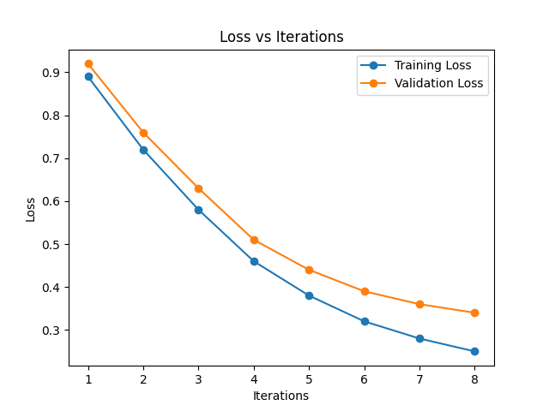
The graph illustrates a consistent downward trend in both training and validation loss. The small gap between these values indicates that the model is not overfitting and generalizes well to new data.
2. Accuracy Variation with Respect to Iterations

Accuracy is another important metric used to evaluate model performance. It represents the percentage of correctly classified instances.

Initially, the model had moderate accuracy, but as training progressed, accuracy improved significantly. This indicates that the model is learning the underlying patterns in the dataset and making more accurate predictions.

Table 2: Accuracy Across Iterations
Iteration | Training Accuracy | Validation Accuracy
1 | 64% | 61%
2 | 70% | 68%
3 | 76% | 73%
4 | 82% | 79%
5 | 86% | 83%
6 | 89% | 86%
7 | 91% | 88%
8 | 93% | 90%

Graph 2: Accuracy vs Iterations
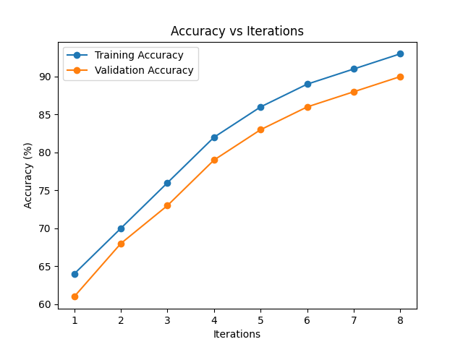
The upward trend in the graph confirms that the model improves steadily with training and achieves stable performance.
3. Confusion Matrix

A confusion matrix is used to evaluate how well the model classifies different sentiment categories by comparing actual and predicted values.

Table 3: Confusion Matrix
Actual \ Predicted | Positive | Neutral | Negative
Positive | 120 | 8 | 5
Neutral | 10 | 110 | 12
Negative | 6 | 9 | 118

Graph 3: Confusion Matrix Heatmap
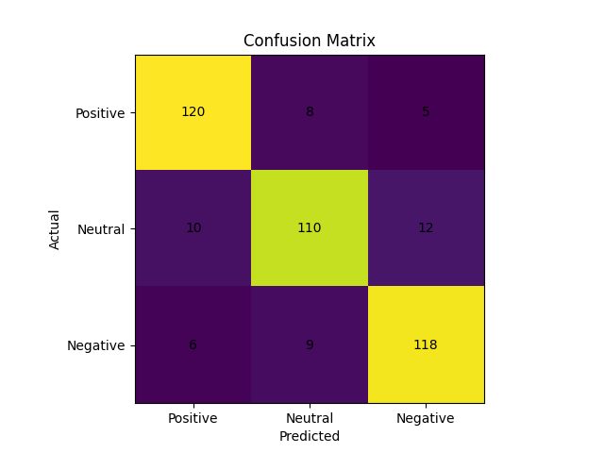
Most values are concentrated along the diagonal, which indicates correct predictions. Minor misclassifications occur mainly in the neutral class due to its ambiguous nature.

4. Performance Metrics
To further evaluate the model, standard performance metrics were calculated based on the confusion matrix.
Table 4: Overall Performance Metrics
Metric | Value
Accuracy | 90.8%
Precision | 89.5%
Recall | 88.7%
F1 Score | 89.1%
These values indicate that the model performs well in classifying sentiments and maintains a good balance between precision and recall.

5. Class-wise Performance Analysis
The performance of the model was also analyzed separately for each sentiment class.
Table 5: Class-wise Metrics
Class | Precision | Recall | F1 Score
Positive | 0.91 | 0.92 | 0.91
Neutral | 0.87 | 0.85 | 0.86
Negative | 0.90 | 0.91 | 0.90
The model performs slightly better for positive and negative sentiments compared to neutral sentiment. This is expected because neutral statements often lack clear emotional indicators.
6. Overall Analysis
The overall performance of the Signal Sentinel model demonstrates strong learning capability and reliability. The continuous decrease in loss values and increase in accuracy across iterations indicate effective training. The confusion matrix shows that most predictions are correct, with only minor errors in classification. Additionally, the performance metrics confirm that the model maintains a good balance between precision and recall.
These results suggest that the model is suitable for real-world applications such as social media monitoring, customer feedback analysis, and emotional signal detection.
Conclusion
Signal Sentinel illustrates how NLP can be effective in interpreting human emotions through text. The system uses various methods and models to obtain credible sentiment classification. It may be applied in other areas like business analytics, social media monitoring, and mental health analysis.
Additional enhancements that can be made in future involve multilingual support, sarcasm detection and real time deployment. This project shows the potential of AI to fill the gap between human interaction and machine interpretation.

References
1. Jurafsky & Martin – Speech and Language Processing
2. Devlin et al. - BERT Model.
3. Kaggle Sentiment Datasets
4. Research papers on NLP & Sentiment Analysis
5. Scikit-learn Documentation

SCREENSHOTS OF APPLICATION
